Name of school or organisation: ……………………………………………………………………….
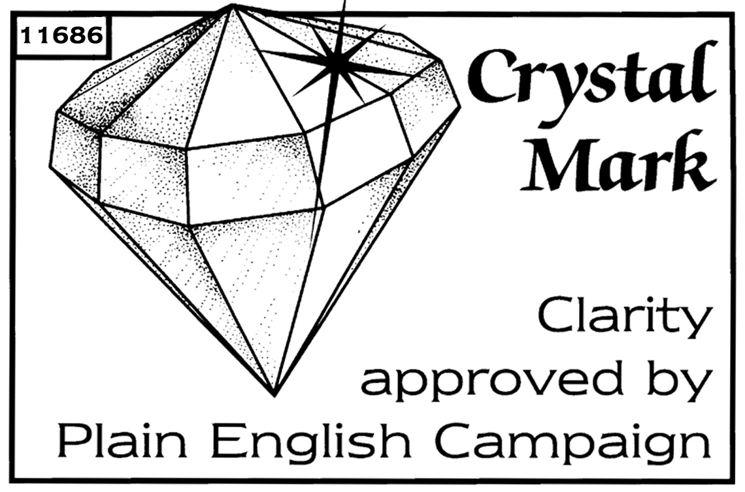
Name of child:....................................................................... Date of birth:.......................................

Town and country of birth:.................................................................................................................

Town of residence: …………………………………………………………………………………………

1 Does the child hold a British passport, or have they been included in one of an older relative?

Yes - please fill in section 2 and 3 and sign the declaration in section 9.
No - please fill in sections 3 to 8 and sign the declaration in section 9.

Passport number | Place of issue | Date of issue | Name of passport holder
…………………….. | ………………………. | ……...……………... | …………………………………………..
2

3 Name, place and date of birth of the mother:.......................................................................................

...........................................................................................................................................................

Name, place and date of birth of the father:.............................................................................................

...........................................................................................................................................................

Date of the parents' marriage:.............................................

4 If the mother or father holds a United Kingdom passport, please give the following information.

 | Passport number | Place of issue | Date of issue
Mother
Father

5 If the child's birth has been registered at a British Embassy, British Consulate General or British Consulate, please give details below of the embassy or consulate, and the date on which the birth was registered.

- Embassy or consulate:........................................................................……………

- Date the birth was registered:...........................................

6 If the child has been registered as a citizen of the United Kingdom and Colonies under the British Nationality Act, please give the following details.

- Number of document:.........................................................................................

- Place and date of issue:......................……….....................................................

7 Please give the full name, place and date of birth of the child's:

 | Place of birth | Date of birth
Maternal grandfather
Name.................................................
Maternal grandmother
Name.................................................
Paternal grandfather
Name.................................................
Paternal grandmother
Name.................................................

8 If any people named above have been registered as citizens of the United Kingdom and Colonies, please give the following information.

 | Number of document | Place of issue | Date of issue
Father
Mother
Maternal grandfather
Maternal grandmother
Paternal grandfather
Paternal grandmother

9 I confirm that I:
a have parental responsibility for the child named above;
b give consent for the child named above to go on the above trip and be included on the collective passport; and
c am not aware of any court order where the child named above cannot be removed from the United Kingdom, or where a third party (such as the other parent or guardian) or the court must give consent for the child named on the previous page to be removed from the United Kingdom.

Signature: ………………………………… Relationship to child:...........................................

Date:………………………………… Contact phone number: ..................................

Who can give consent? If a child's parents are married, either parent can give consent. If the parents were not married at the time of the birth (or when the mother became pregnant, for those living in Scotland), only the mother can give consent. The father can give consent if the parents then marry each other, or if the father has a parental responsibility order or agreement.
Parental consent Either parent with parental responsibility can give consent. If someone acting as a guardian gives consent, they should send a letter explaining the circumstances. It should be supported by a letter from the head teacher or someone similar who is aware of the facts, confirming the circumstances.
Child's change of name If the child's name has changed since birth, the parent or guardian signing needs to confirm that everyone with parental responsibility is aware of and agrees to the change of name.
Children in care In all cases, we need a letter from the social services department. The letter must say what section of the Children’s Act the child is in care under. For more advice, please call the Passport Adviceline on 0300 222 0000

