Name of school or organisation: ………………………………………………………………………….
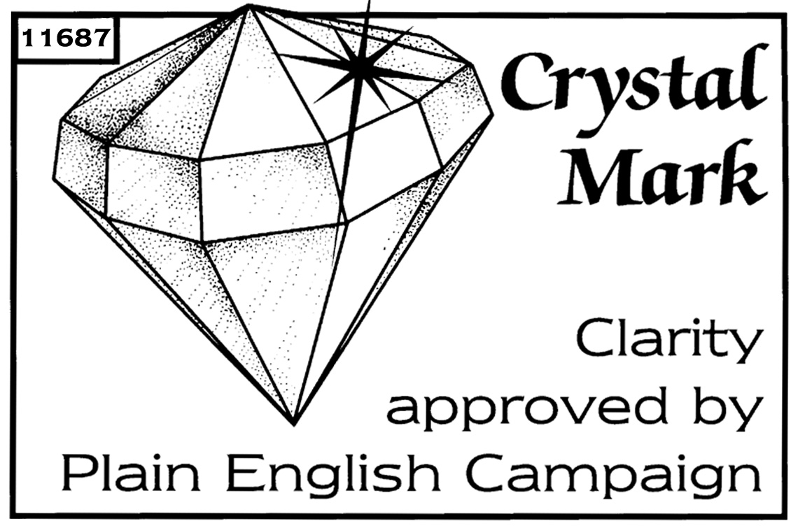
Name of child: ....................................................................... Date of birth: ............................

Town and country of birth: ...............................................................................................................

Town of residence: …………………………………………………………………………………………

1 Does the child hold a British passport, or have they been included on one of an older relative?
Yes – please fill in sections 2 and 4 and sign the declaration in section 5.
No – please fill in sections 3 and 4 and sign the declaration in section 5.

2
Passport number | Place of issue | Date of issue | Name of passport holder
………………………. | …………………………. | …………………… | ……………………………………….

3 Does the child have a parent born in the UK or registered or naturalised as a British citizen (applied for British citizenship through the Home Office)?
If you have answered ‘No’, please say if there were any restrictions on either the mother's or father's stay in the UK when the child was born. Please use the other side of this form to provide details.

Yes
No

4 Name, place and date of birth of the mother:.................................................................................

...........................................................................................................................................................

Name, place and date of birth of the father: ......................................................................................

...........................................................................................................................................................

Date of the parents' marriage: ..............................................

If both parents named above were born after 31 December 1982 or were born abroad, we will also need the full name, town, country, date of birth and date of marriage of the child's grandparents (or details of the parents' claim to British nationality). Please use the other side of this form to provide details.

5 I confirm that I:
a have parental responsibility for the child named above;
b give consent for the child named above to go on the above trip and be included on the collective passport; and
c am not aware of any court order where the child named above cannot be removed from the United Kingdom, or where a third party (such as the other parent or guardian) or the court must give consent for the child named above to be removed from the United Kingdom.
Signature: ………………………………… Relationship to child:...........................................

Date:………………………………… Contact phone number:.................................
Who can give consent? If a child's parents are married, either parent can give consent. If the parents were not married at the time of the birth (or when the mother became pregnant, for those living in Scotland), only the mother can give consent. However, the father can give consent if the parents then marry each other, or if the father has a parental responsibility order or agreement.
Parental consent Either parent with parental responsibility can give consent. If someone acting as a guardian gives consent, they should send a letter explaining the circumstances. It should be supported by a letter from the head teacher or someone similar who is aware of the facts, confirming the circumstances.
Child's change of name If the child's name has changed since birth, the parent or guardian signing needs to confirm that everyone with parental responsibility is aware of and agrees to the change of name.
Children in care In all cases, we need a letter from the social services department. The letter must say what section of the Children’s Act the child is in care under. For more advice, please call the Passport Adviceline on 0300 222 0000

Child's change of name
If the child's name has changed since birth, the parent or guardian signing needs to confirm that everyone with parental responsibility is aware of and agrees to the change of name.

If you have answered ‘No’, please say if there were any restrictions on either the mother's or father's stay in the UK when the child was born. Please use the other side of this form to provide details.

